New opera poignantly puts life in death | Review
By MATTHEW J. PALM
ORLANDO SENTINEL ARTS CRITIC |
FEB 20, 2021 AT 5:00 AM
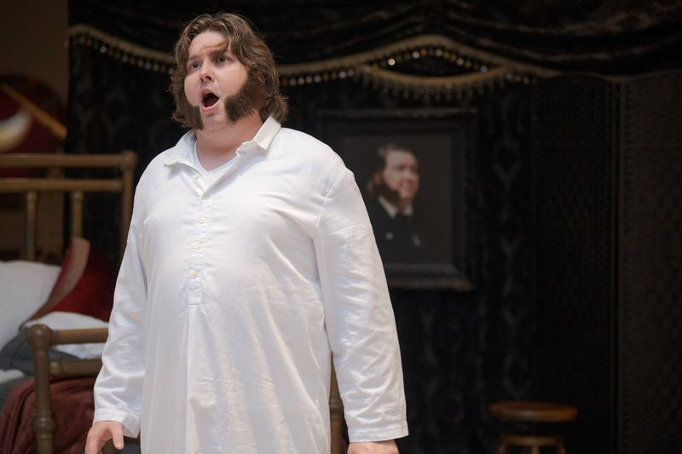
Sean Christopher Stork sings the title role of Opera Orlando's "Death of Ivan Ilych." (Opera Orlando / Courtesy photo)

There’s no spoiler in the title “Death of Ivan Ilych”: Ivan’s death has occurred before the music starts. But from that inevitable end, we flash back to the Russian’s final weeks, from his first pains to his last breath.
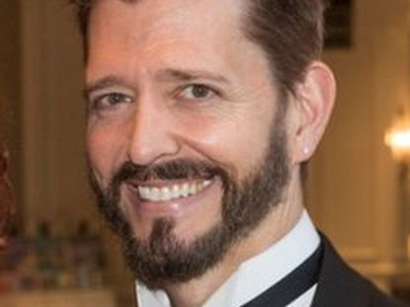

World premiere: Composer turned to ‘Death’ after beating cancer
FEB 16, 2021 AT 7:07 AM
Based on Leo Tolstoy’s revered 1886 novella, “Death of Ivan Ilych” is the first opera from composer John Young and librettist Alan Olejniczak. Opera Orlando presented the one-act’s world premiere Friday in partnership with Thompson Street Opera Company in Chicago, where the work will next be staged.

For literature buffs, there’s great joy to see the novella’s deliciously vivid opening scene come to life. Ivan’s widow, Praskovya Fedorovna, is more pragmatic than grief stricken. She worries about the cost of the funeral service and the amount of her widow’s pension. Mourner Pytor, there from a sense of duty rather than real feeling, squirms uncomfortably.
Young’s music, richly orchestrated for string quintet, piano and oboe, keenly highlights the mournful situation and its awkwardness.
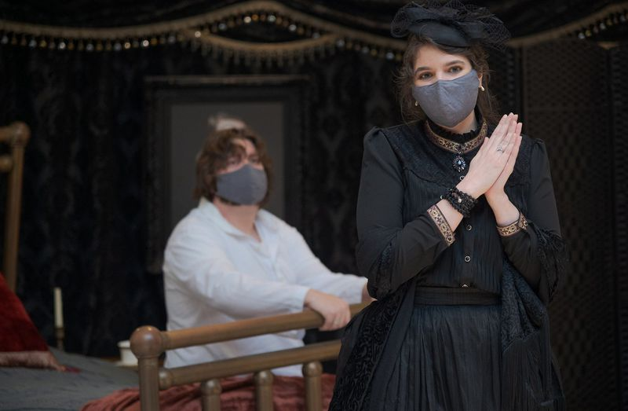
Sean Christopher Stork and Adriana V. Nieves play a couple whose love has faded in Opera Orlando's production of "Death of Ivan Ilych." (Opera Orlando / Courtesy photo)

As performed by Alterity Chamber Orchestra members under the direction of Deniz Uz, the music’s emotion was clearly indicated on Friday. When Praskovya bursts into her husband’s sickroom, the music shoots a jolt of energy — and life — into the moment.
As Ivan’s suffering worsens we hear jangled piano chords and attacks on the keyboard. High-pitched strings sound like angel wings. One of the most moving melodies — and moments, as staged by Grant Preisser — is a haunting refrain, sung poignantly by Adriana V. Nieves as Praskovya over her sleeping child.

Sometimes, the music could use more staging; one sequence left the audience watching Sean Christopher Stork, as Ivan, lying in bed for an uncomfortably long time. Maybe here’s a chance to show how his illness affects his family?
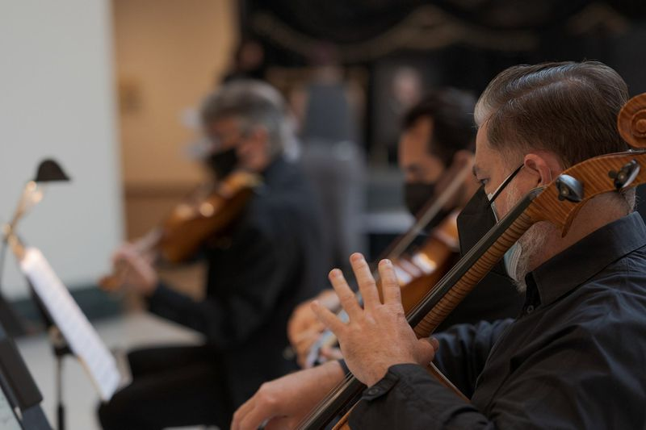
Musicians from Alterity Chamber Orchestra played for Opera Orlando's production of "Death of Ivan Ilych." (Opera Orlando / Courtesy photo)

The duets thrill, especially a point-counterpoint between an Orthodox priest (well sung by Jose-Manuel Lopez) and Ivan. A wistful love duet between Ivan and wife satisfies musically but softens the pair’s coldness from the original story, making the opening scene a little less believable.
In fact the work could use sharper theatrical edges in a few key places: A more definitive scene setter of Ivan’s pre-illness home life early on to contrast with his end, for example, and Ivan’s rock bottom could descend even deeper before he comes to terms with his fate.
Olejniczak has carefully and effectively mixed Tolstoy’s memorable words and details with his own, and Stork does justice to Ivan’s painful self-discoveries. Ivan’s servant Gerasim, sweetly sung by Brent Doucette, plays a selfless almost Christ-like role in the story and could use a little more to do — something the creators said was in the works during a post-show talkback.
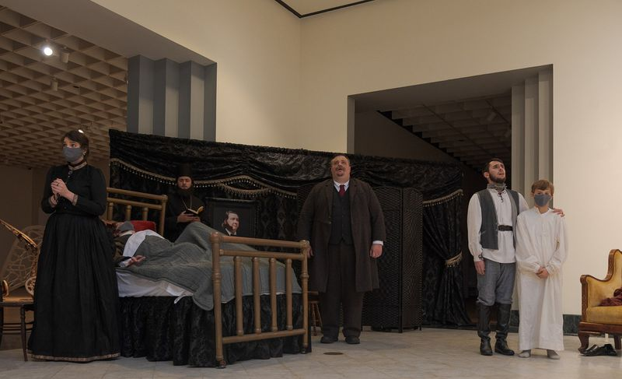
The company of "Death of Ivan Ilych," given its world premiere by Opera Orlando on Feb. 19, 2021. (Opera Orlando / Courtesy photo)

Based on a well-known and well-loved story, with evocative music and manageable cast size and production requirements, “Death of Ivan Ilych” is sure to have operatic life, however it evolves. Orlando was fortunate to witness its birth.

‘Death of Ivan Ilych’
- Length: 80 minutes plus talkback
- Where: Orlando Museum of Art, 2416 N. Mills Ave.
- When: 5 p.m. Feb. 21
- Cost: $77.25, which includes pre- and post-show appetizers, drinks and desserts; only a few tickets remain
- Info: operaorlando.org/ivan

